Ideation Phase
Define the Problem Statements

Date | 31 January 2026
Team ID | Team 1
Project Name | Automating Data Import and Relationship Mapping using Import Sets and Dot Walking
Maximum Marks | 2 Marks

Our Problem Statement:
Our organization wants to regularly import a list of new employees with their details, such as Name, Email, Department, and Manager, from an external system. Once imported, when an Incident is assigned to an employee, the Incident form should automatically show the manager's email of the employee's department.

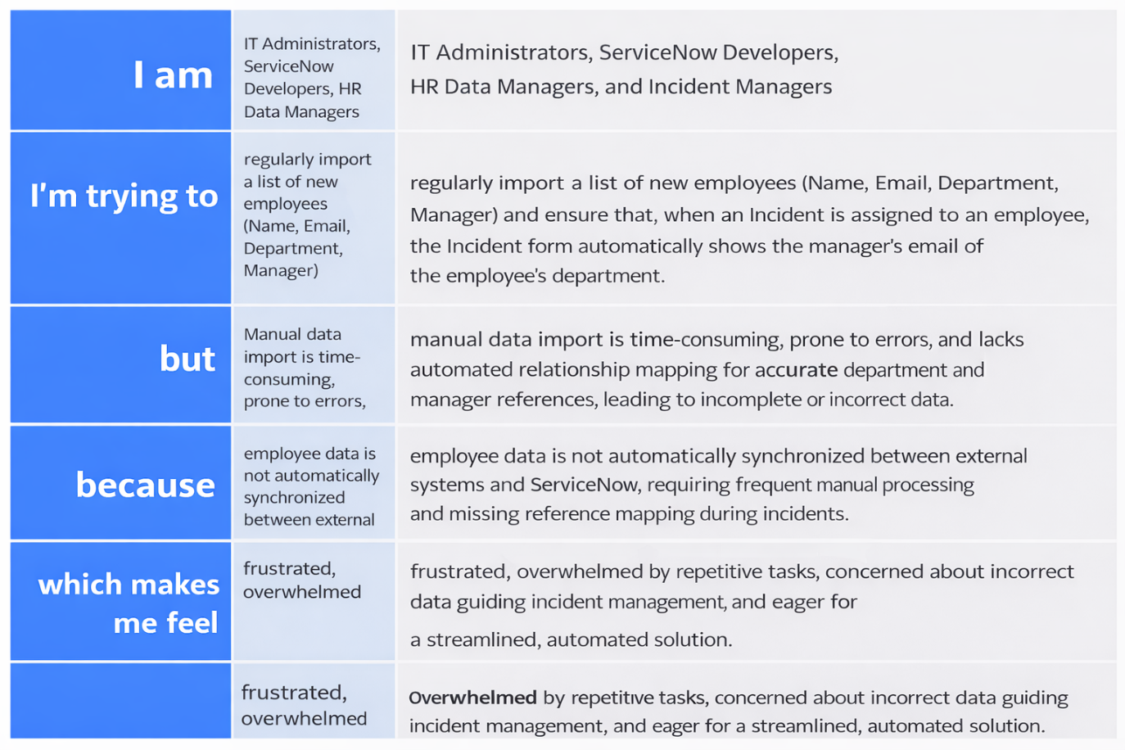

Problem Statement (PS) | I am (Customer) | I'm trying to | But | Because | Which makes me feel
PS-1 | A ServiceNow System Administrator | regularly sync new employee details (Name, Dept, Manager) from an external system into the platform... | the current method is manual, time-consuming, and prone to data relationship errors... | we lack an automated pipeline using Import Sets and Transform Maps. | overwhelmed by manual data entry and inefficient.
PS-2 | An IT Support Agent | quickly identify an employee's department and manager to escalate an assigned Incident... | I have to manually navigate away from the Incident form to dig through the user's profile... | the Incident form does not automatically surface related reference data (dot-walking). | frustrated by unnecessary clicks and slowed down in my resolution time.

